1. <https://github.com/in28minutes/MockitoTutorialForBeginners>
2. System Under Test: For which we write unit test.
3. Dependency For System Under Test: Say TodoBusinessImpl is SUT and it uses TodoService so TodoService is dependency for SUT.
4. **Stub Class**: Sample implementation to return sample Data. Stub is only used for Unit Testing.

Static Import Configuration for Mockito

1. 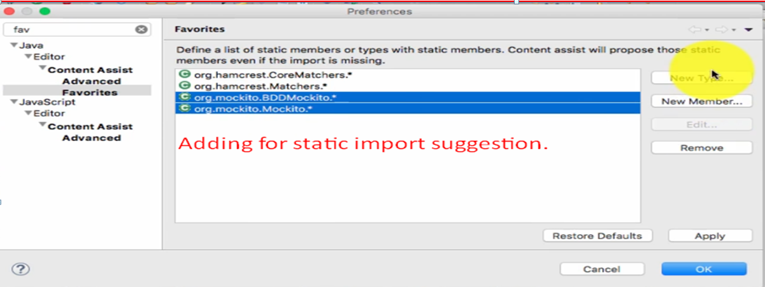

Mock

1. org.mockito.Mockito.mock
   1. when(mockTodoService.retrieveTodos("jatin")).thenReturn(Arrays.asList("Lear Spring", "B", "C"));
2. 